Exercises: Linear Data Structures – Stacks and Queues
This document defines the exercise assignments for the "Data Structures" course @ Software University. You can submit your code in the SoftUni Judge System - https://judge.softuni.bg/Contests/567/Linear-Data-Structures-Stacks-and-Queues-CSharp-Exercise.

Reverse Numbers with a Stack
Write a program that reads N integers from the console and reverses them using a stack. Use the Stack<int> class from .NET Framework. Just put the input numbers in the stack and pop them. Examples:
Input | Output
1 2 3 4 5 | 5 4 3 2 1
1 | 1
(empty) | (empty)
1 -2 | -2 1

Calculate Sequence with a Queue
We are given the following sequence of numbers:
- S₁ = N
- S₂ = S₁ + 1
- S₃ = 2*S₁ + 1
- S₄ = S₁ + 2
- S₅ = S₂ + 1
- S₆ = 2*S₂ + 1
- S₇ = S₂ + 2
- …
Using the Queue<T> class, write a program to print its first 50 members for given N. Examples:
Input | Output
2 | 2, 3, 5, 4, 4, 7, 5, 6, 11, 7, 5, 9, 6, …
-1 | -1, 0, -1, 1, 1, 1, 2, …
1000 | 1000, 1001, 2001, 1002, 1002, 2003, 1003, …

Implement an Array-Based Stack
Implement the "stack" data structure Stack<T> that holds its elements in an array:
public class ArrayStack<T>
{
private T[] elements;
public int Count { get; private set; }
private const int InitialCapacity = 16;
public ArrayStack(int capacity = InitialCapacity) { … }
public void Push(T element) { … }
public T Pop() { … }
public T[] ToArray() { … }
private void Grow() { … }
}
Follow the concepts from the CircularQueue<T> class from the exercises in class. The stack is simpler than the circular queue, so you will need to follow the same logic, but more simplified. Some hints:
- The stack capacity is this.elements.Length
- Keep the stack size (number of elements) in this.Count
- Push(element) just saves the element in elements[this.Count] and increases this.Count
- Push(element) should invoke Grow() in case of this.Count == this.elements.Length
- Pop() decreases this.Count and returns this.elements[this.Count]
- Grow() allocates a new array newElements of size 2 * this.elements.Length and copies the first this.Count elements from this.elements to newElements. Finally, assign this.elements = newElements
- ToArray() just creates and returns a sub-array of this.elements[0…this.Count-1]
- Pop() should throw InvalidOperationException (or IllegalArgumentException) if the stack is empty

Linked Stack
Implement a stack by a "linked list" as underlying data structure:
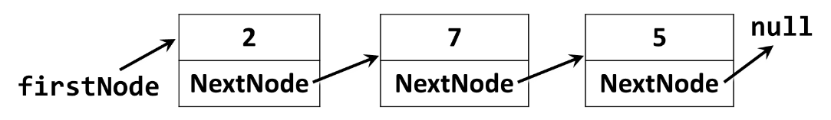
Use the following code as start:
public class LinkedStack<T>
{
private Node<T> firstNode;
public int Count { get; private set; }
public void Push(T element) { … }
public T Pop() { … }
public T[] ToArray() { … }
private class Node<T>
{
private T value;
public Node<T> NextNode { get; set; }
public Node(T value, Node<T> nextNode = null) { … }
}
}
The Push(element) operation should create a new Node<T> and put it as firstNode, followed by the old value of the firstNode, e.g. this.firstNode = new Node<T>(element, this.firstNode).
The Pop() operation should return the firstNode and replace it with firstNode.NextNode. If the stack is empty, it should throw InvalidOperationException.

Linked Queue
Implement a queue by a "doubly-linked list" as underlying data structure:
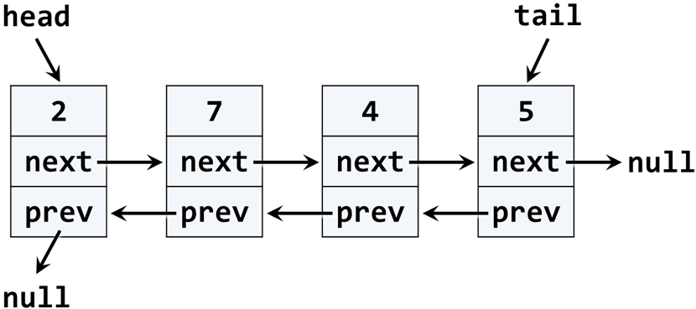
Use the following code as start:
public class LinkedQueue<T>
{
public int Count { get; private set; }
public void Enqueue(T element) { … }
public T Dequeue() { … }
public T[] ToArray() { … }

private class QueueNode<T>
{
public T Value { get; private set; }
public QueueNode<T> NextNode { get; set; }
public QueueNode<T> PrevNode { get; set; }
}
}
You may modify and adjust the code from the DoublyLinkedList<T> class from the last lesson. If the queue is empty, the Dequeue() should throw InvalidOperationException.

* Sequence N M
We are given numbers n and m, and the following operations:
- n n + 1
- n n + 2
- n n * 2
Write a program that finds the shortest sequence of operations from the list above that starts from n and finishes in m. If several shortest sequences exist, find the first one of them. Examples:
Input | Output
3 10 | 3 -> 5 -> 10
5 -5 | (no solution)
10 30 | 10 -> 11 -> 13 -> 15 -> 30
Hint: use a queue and the following algorithm:
- create a queue of numbers
- queue n
- while (queue not empty)
  - queue e
  - if (e < m)
    - queue e + 1
    - queue e + 2
    - queue e * 2
  - if (e == m) Print-Solution; exit
The above algorithm either will find a solution, or will find that it does not exist. It cannot print the numbers comprising the sequence n m.
To print the sequence of steps to reach m, starting from n, you will need to keep the previous item as well. Instead using a queue of numbers, use a queue of items. Each item will keep a number and a pointer to the previous item. The algorithms changes like this:
Algorithm Find-Sequence (n, m):
- create a queue of items { value, previous item }
- queue { n, null }
- while (queue not empty)
  - queue item
  - if (item.value < m)
    - queue { item.value + 1, item }
    - queue { item.value + 2, item }
    - queue { item.value * 2, item }
  - if (item.value == m) Print-Solution; exit
Algorithm Print-Solution (item):
- while (item not null)
  - print item.value
  - item = item.previous

